solution

Project Management Software

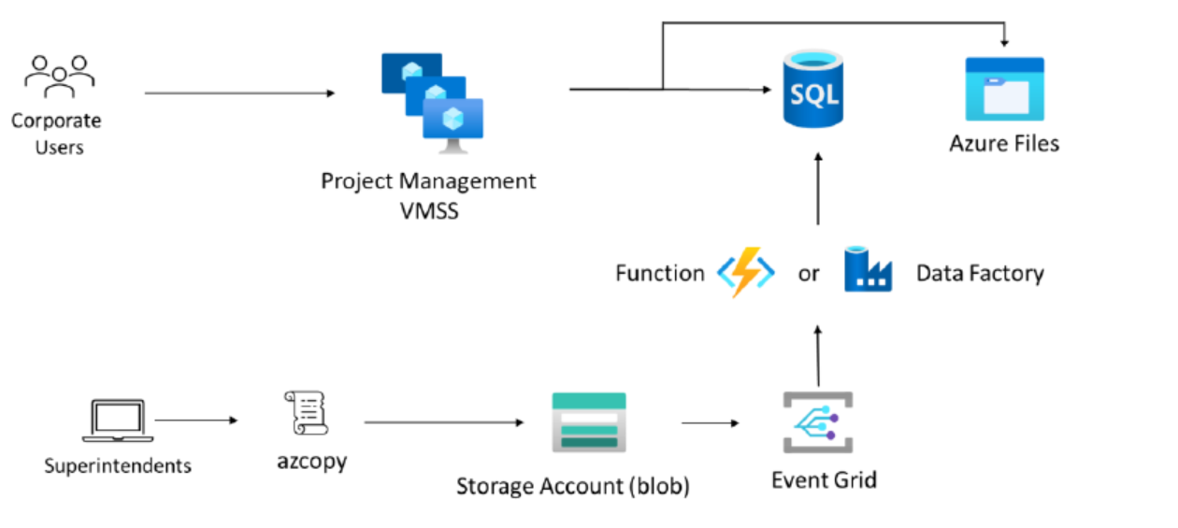

• A VM Scale Set could be used to run the project management software. As the software already runs on an NLB cluster, it is highly likely that it would function correctly on a VMSS. VM Scale Sets would also allow for health probes and self-healing in the even one of the project management servers stopped working. Since the software is provided by a third-party vendor, it would require vendor support to run in an App Service or container. It may be worth contacting the vendor to determine if that is a choice.

• An Azure SQL Database should be the first choice for the project management database. The general tier does provide some redundancies. If more redundancy is required, the database can be upgraded to the Business-Critical tier.

• Azure Files should be used to replace the NAS functionality as it provides SMB (mapped drive) support for the Project Management software

• Blob storage should be used to replace the FTP server. Blob storage provides the features and security necessary at the lowest price point. Azure Files may work but would come at a higher price.

• The script used by the superintendents should be upgraded to use a tool such as AZCopy. AZCopy can directly copy files to the blob storage from the local machines.

• Event Grid can be used to trigger data import immediately after superintendents’ upload change files.

• Azure Data Factory or an Azure Function App could be used to import the change files into the database. Azure Data Factory would provide an easier, no-code path. If the workflow requires more flexibility, an Azure Function could be custom written.

• Consider using Private Endpoints for PaaS services to improve security.